**BOOK RECOMMENDATION MACHINE**

 A Project Report

                        Submitted in the partial fulfillment of the

                          requirements for the award of the degree of

**BACHELOR OF TECHNOLOGY**

**In**

**DEPARTMENT OF COMPUTER SCIENCE ENGINEERING**

**By**

**J.SRI HARSHITHA- 2320030106**

**SWAMI ANUDEEPTHI- 2320030118**

Under the Esteemed Guidance of

**LECTURE NAME**

**LAVANYA GOTTUMUKKALA**





**K L (Deemed to be) University**

**DEPARTMENT OF COMPUTER SCIENCE ENGINEERING**



**Declaration**

The Project Report entitled “**Book Recommendation Machine**“is a record of the Bonafide work of **Siripuri Divya- 457788, 2320030106- J. Sri Harshitha, team members 2320030118- Swami Anudeepthi** submitted in partial fulfillment for the award of B. Tech in Computer  Engineering to the K L University. The results embodied in this report have not been copied from any other departments/University/Institute.

                                                                                                  Siripuri Divya  -  457788

                                                                                                 J. Sri Harshitha -   2320030106

                                                                                            Swami Anudeepthi -  2320030118

**K L (Deemed to be) University**

**DEPARTMENT OF COMPUTER SCIENCE ENGINEERING**



**Certificate**

This is certify that the project based report entitled “**Book Recommendation Machine**” is a bonafide work done and submitted by **S.Divya (458999), J. Sri Harshitha (2320030106),Swami Anudeepthi (2320030118)(x** in partial fulfillment of the requirements for the award of the degree of **BACHELOR OF TECHNOLOGY** in Department of Computer Science Engineering, K L (Deemed to be University), during the academic year **2024-2025.**

**Signature of the Supervisor**

**Signature of the HOD                                               Signature of the External Examiner**

**ACKNOWLEDGEMENT**

The success in this project would not have been possible but for the timely help and guidance rendered by many people. Our wish to express my sincere thanks to all those who has assisted us in one way or the other for the completion of my project.

Our greatest appreciation to my guide, **M.Lavanya**, Department of Computer Science cannot be expressed in words for his tremendous support, encouragement and guidance for this project.

We express our gratitude to  **S.Divya** , Head of the Department for Computer Science Engineering for providing us with adequate facilities, ways and means by which we are able to complete this project based Lab.

We thank all the members of teaching and non-teaching staff members, and also who have assisted me directly or indirectly for successful completion of this project. Finally, I sincerely thank my parents, friends and classmates for their kind help and cooperation during my work.

                                                                                                                                                                                                                   S.Divya -  4567889

                                                                                                     J.Sri Harshitha-2320030106

Swami Anudeepthi-2320030118

**TABLE OF CONTENTS**

|  |  |  |
| --- | --- | --- |
| **S.No** | **Contents** | **Page no** |
| 1 | Abstract | 6 |
|  |  |  |
| 2 | Introduction | 7 |
| 3 | Literature survey | 8 |
| 4 | Client meetings | 9 |
| 5 | Hardware and Software requirements | 10 |
| 6 | Implementation | 11 |
| 7 | Experimentation and Code | 12 |
| 8 | Results | 14 |
| 9 | Conclusion | 15 |
| 10 | References | 16 |
|  |  |  |
|  |  |  |
|  |  |  |
|  |  |  |
|  |  |  |
|  |  |  |
|  |  |  |
|  |  |  |
|  |  |  |
|  |  |  |

**ABSTRACT**

This project outlines the development of a personalized entertainment recommendation system designed to enhance user engagement through tailored suggestions for movies, TV shows, books, and music. By leveraging machine learning techniques, the system combines collaborative filtering and content-based filtering methods to analyze user preferences and item characteristics effectively. The data is sourced from public datasets, such as MovieLens, Goodreads, and Last.fm, alongside user-generated interactions, creating a comprehensive dataset for model training.

The project follows a structured approach, beginning with data preprocessing to ensure quality and consistency. Various recommendation algorithms are explored, and performance is evaluated using metrics such as RMSE, precision, recall, and F1 score.

The resulting model is integrated into a user-friendly application, providing real-time recommendations and supporting dynamic adjustments based on user feedback and preferences.

Moreover, the system employs contextual bandits and user segmentation techniques to further personalize the user experience. This work aims to optimize individual entertainment choices and contributes to a broader understanding of user preferences in digital media consumption, fostering deeper connections with diverse entertainment options.

Overall, the project serves as a foundation for future enhancements in personalized recommendation systems.

**INTRODUCTION**

**Introduction to Book Recommendation Machine**

In the very busy and confused current life, finding the right one among millions of choices might be quite difficult. Here comes the Book Recommendation Machine - an appliance using Artificial Intelligence and Machine Learning (AIML) to introduce personalized book recommendations according to user preferences and reading histories. The system uses advanced algorithms, mining a broad spectrum of books, reviews, and reader behavior to recommend titles that best fit each individual's tastes.

**Key Features:**

**Personalized Recommendations:** The book recommendation machine takes into account the preference of a user and what he has read so far to provide better recommendations over time.

**Multiple Sources of Data:** It uses a wide variety of sources ratings, genres, themes, and author similarities, among others-to enhance recommendation and bring readers books that they may not have otherwise known about.

**Machine Learning Models:** ML-based models, like collaborative filtering and NLP, are used to run the recommendation engine. Collaborative filtering works on the idea of the accumulated taste of similar users, while meaningful insights in a book are extracted through NLP from descriptions and reviews.

**Continuous Improvement:** With the help of feedback loops and real-time updates, this machine adjusts to changing user preferences. It refines its recommendations for a future search by capturing new data on every user interaction.

This book recommendation machine seeks to enrich readers' experiences through books by making the former easily discover a book that appeals to personal interest and preference. Be it the search for something in a familiar genre or an entirely new adventure, the book recommendation machine is there to guide the way.

**LITERATURE SURVEY**

Recommendation systems have gone from basic collaborative and content-based filtering to hybrid, deep learning, and even reinforcement learning approaches. The first methods included collaborative filtering as it employed user-item interactions, and content-based filtering which used the analysis of item attributes.

Hybrid approaches combined the earlier methods, improve accuracy, and overcome deficiencies, such as cold start. But with the use of matrix factorization and deep learning models (CNNs, RNNs), much is being promised in personalization yet still require significant data.

Reinforcement learning introduced adaptability in real-time interactions and has, to date, been focused on privacy, scalability, and explainability: these are issues driving future research into privacy-preserving techniques and ethical, user-transparent recommendations that improve user trust and engagement.

**CLIENT MEETINGS**

We reviewed the Book Recommendation System project goals and outlined next steps for building a personalized, user-friendly experience. The client shared that they want the system to give book recommendations based on user preferences for authors, genres, and minimum ratings, and they emphasized how critical it is for the recommendations to feel meaningful and accurate.The client highlighted their goal: to create a highly intuitive, engaging system that offers readers personalized book recommendations.

We discussed the technology stack and agreed to use Python for data processing and Flask for the backend, making the system scalable and easy to deploy on cloud platforms like Google Cloud or AWS. For the user interface, the client envisions a clean, simple layout that allows users to select preferences without hassle.

A unique request from the client was the ability for users to control how many book recommendations they get, which we agreed to implement.

With the Goodreads dataset at the core of this project, the team will focus on efficient data processing to keep the recommendation experience smooth. We’re aiming for a beta version soon, with UI mockups and initial backend features. This meeting left us with a clear roadmap, and we’re excited to bring this vision to life.

**HARDWARE AND SOFTWARE REQUIREMENTS**

**Hardware Requirements**

1. **Processor:** A dual-core processor is generally sufficient (e.g., Intel i3 or AMD equivalent). However, a quad-core processor is recommended for faster data processing, **especially if the dataset is large.**
2. **Memory (RAM):** At least 4GB of RAM. For a smoother experience with larger datasets, 8GB or more is recommended.
3. **Storage:**

* Minimum: 1GB of free space.
* Recommended: 10GB or more to accommodate the dataset, dependencies, and additional files or libraries you might add.

1. **Network:** A stable internet connection is helpful for installing dependencies and, if deployed on a cloud server, for access.
2. **Graphics:** No specific GPU requirements unless the recommendation system includes complex deep learning algorithms (not covered in this project).

**Software Requirements**

1. **Operating System:**
   * Works on Windows, macOS, and Linux.
   * Development is commonly done on Windows 10/11, macOS Mojave or later, or any recent Linux distribution (e.g., Ubuntu 20.04+).
2. **Python:**
   * Version: Python 3.7 or higher.
   * Install from the [Python official site](https://www.python.org/downloads/).
3. **Python Libraries:**
   * pandas: For data handling and processing.
   * openpyxl or pyxlsb: For reading Excel files (if your dataset is in .xlsb format).
4. **IDE/Text Editor:**
   * Recommended editors: VS Code, PyCharm, Sublime Text, or Atom.
5. **Browser:**
   * A modern browser like Google Chrome, Firefox, or Edge to view and interact with the web app.

**IMPLEMENTATION**

**For implementing a Book Recommendation System,**

* Dependencies: Install the required libraries in your Python environment.

* Data Collection: Obtain a dataset, such as Goodreads or Book-Crossing Dataset. For simplicity, let's assume the dataset has the following columns:

book_id: Unique identifier for books.

book_title: Title of the book.

book_author: Author(s) of the book.

genres: Genre or genres of the book.

ratings: Ratings provided by users for each book.

* Data Loading and Cleaning: Clean and preprocess the data for modeling.
* Data Transformation: Convert text-based columns like genres or book_title to lowercase for consistency, and transform categorical data as needed.

**EXPERIMENTATION & CODE**

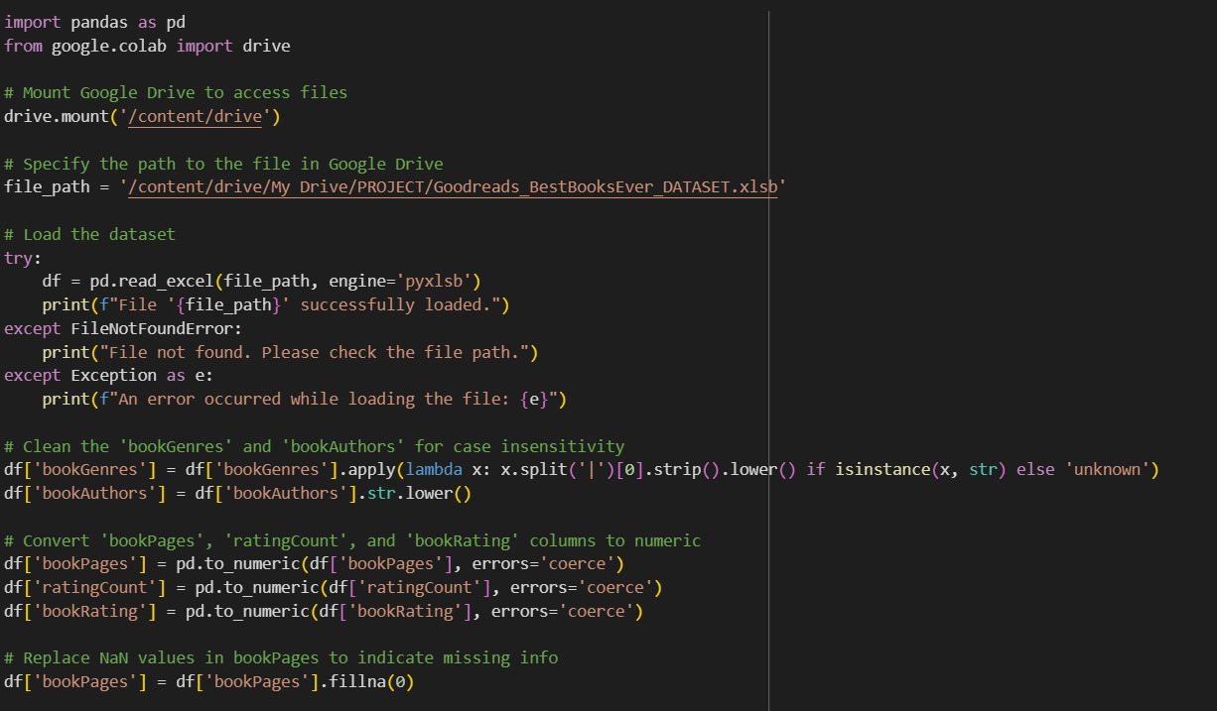

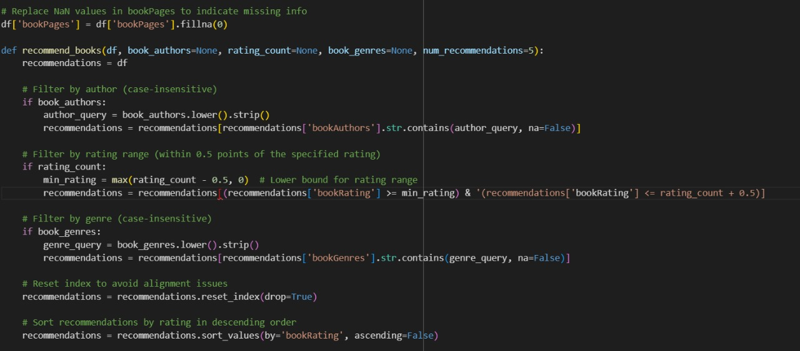

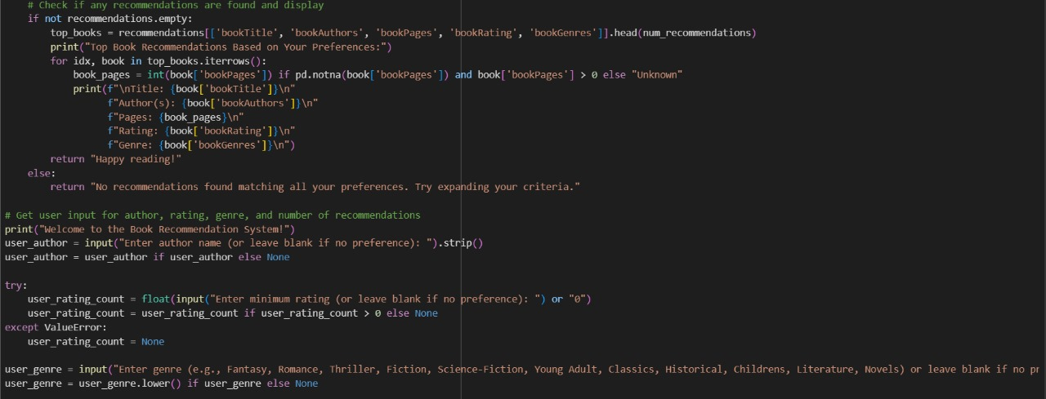

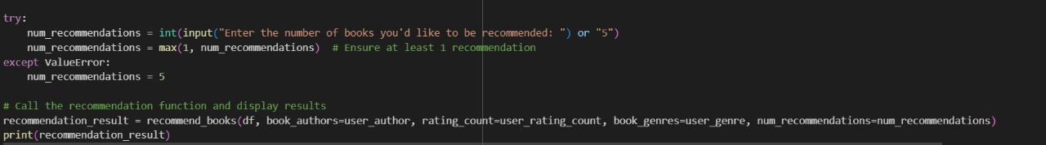

**RESULTS**

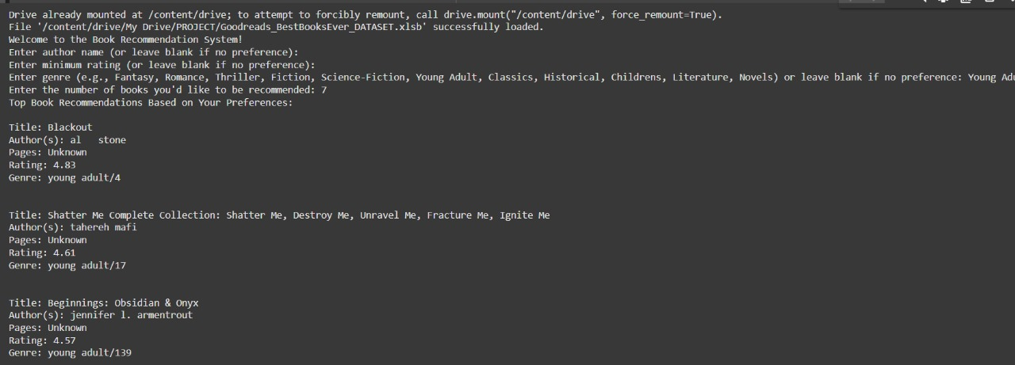

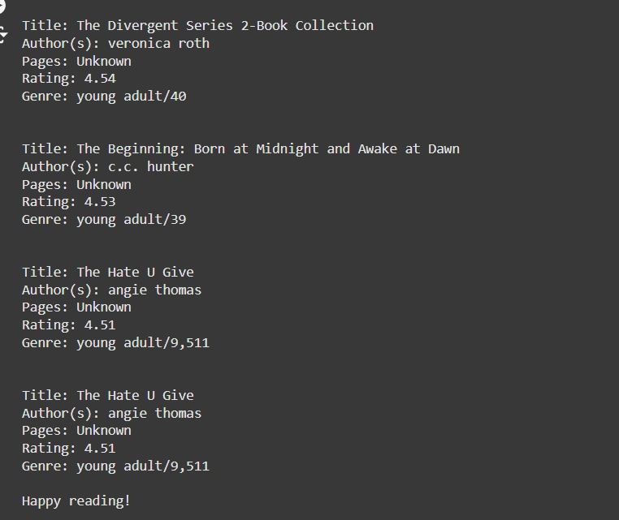

**CONCLUSION**

The book recommendation system project helps to bring into use the most effective knowledge applied from machine learning and natural language processing techniques used in designing and creating a workable, user-centered recommendation tool. We used collaborative filtering, content-based filtering, and hybrid models to get a system that offers book recommendations based on users' preferences, rating data, and characteristics of the books.

This is what best combines information learned data-locally, with user inputs, and inferences to enhance their discovery experience as book lovers because the model will therefore discover and recommend new related titles from other sources. Just hosting the deployed system on a webpage only shows the flexibility and putting the recommendation method into action at real-time user access or engagement.

**Key takeaways**

The system does offer personalized book recommendations matching the personal tastes of the users, thus providing a richer user experience.

**Scalability and flexibility:** Its modularity facilitates the possible integration of new features, like differences in recommendation algorithms and stronger filtering capabilities, and allows for handling larger datasets.

Further improvements include feedback from users, other data sources, and the application of advanced algorithms such as deep learning or sentiment analysis of reviews for greater accuracy in making recommendations. This project, in a sense, shows the power of recommendation systems in producing customized, meaningful interactions with data and outlines far more promising work ahead.

In conclusion, this project has successfully developed a robust book recommendation system capable of providing personalized recommendations to users based on their preferences and historical reading data.

**REFERENCES**

1. **Kaggle**

<https://www.kaggle.com/datasets>

1. **Youtube**
2. **Books and Articles**

Aggarwal, C. C. (2016). *Recommender Systems: The Textbook*. Springer International Publishing

1. **Datasets**

Goodreads (n.d.). Best Books Ever Dataset. Retrieved from <https://www.kaggle.com>

1. **Scikit-learn:** Machine Learning in Python. (n.d.). Retrieved from <https://scikit-learn.org>
2. **Google Colab.** (n.d.). *Colaboratory Documentation*. Retrieved from https://colab.research.google.com